Comments 10
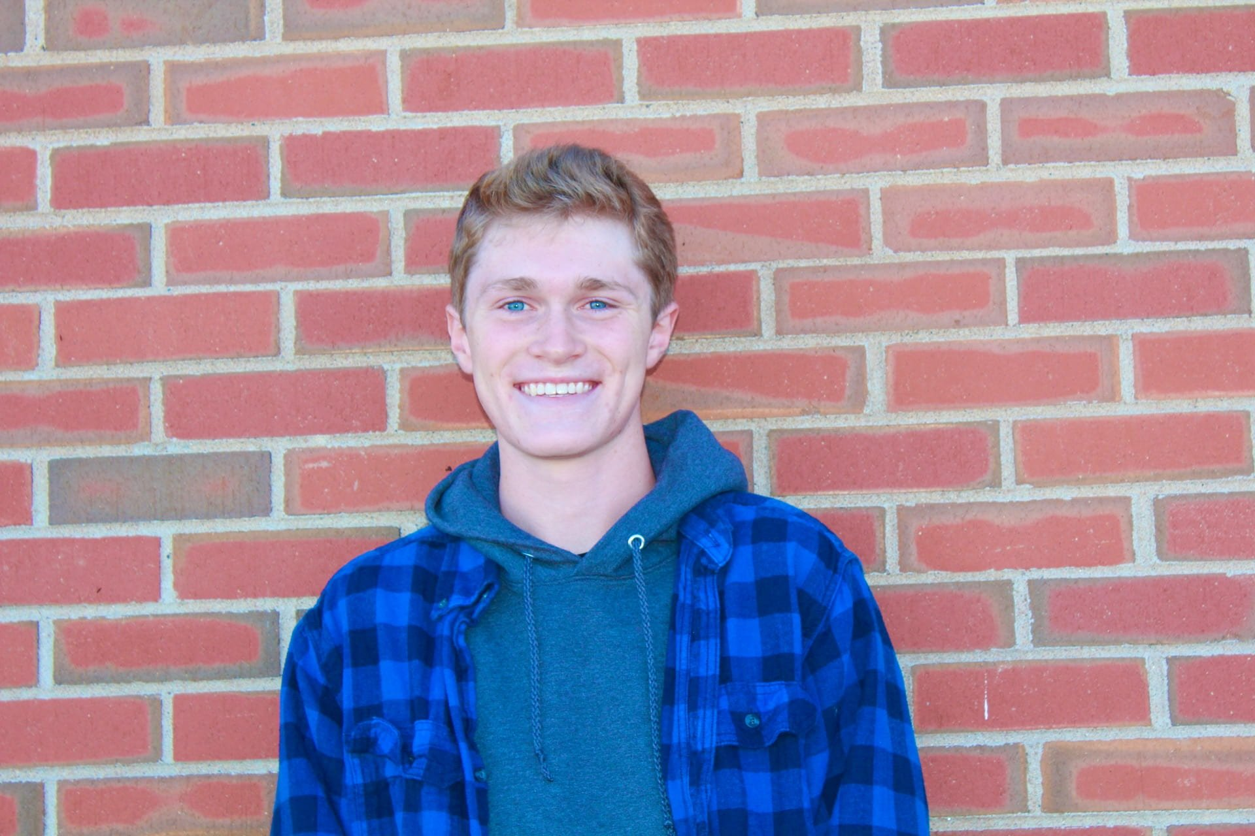
Photo by Morgan Gallegos
I like your picture of happy Josh because the contrast that you use really brings out all of the colors especially in his eyes.

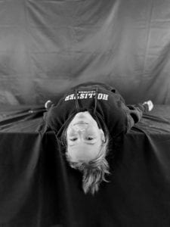
Photo by Tegan
I like this picture of Jocie because I feel like it shows her personality in a way and i like how you made everything black and white.

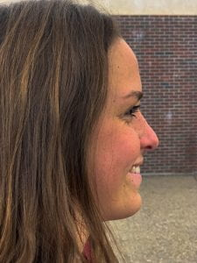
Photo by: alexia
I like this picture because it shows a really good side profile of Steph and she looks really happy in it.

Photo by Aysia
I like this picture because it doesn’t look staged. It looks natural and the lighting and contrast really makes things pop.

