Comments 11
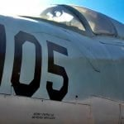
Photo by Morgan
I like this photo because of the angle you took it at. You can see another prospective of the plane and you can see how small the area for the pilots were.

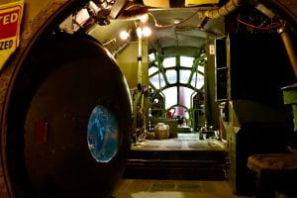
Photo by Jocie
I like this photo because if gives a good look of the inside of the plane and how little room there was inside. I also think this is a cool photo because it almost elongates the plane because of the angle you took it at.

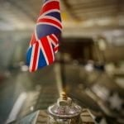
Photo by Gracie
I like this picture because the main focus is on the flag and the back pf the photo is blurry.

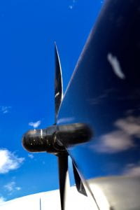
Photo by Aysia
I really like this picture because of the angle that you took it at. I like how you can see the propellers and how that is your main focus, but I think that the sky in the back really pulls it all together. I also like how you can see the reflection of clouds on the propeller.

