Dorothea Lange Writing
The way that I would define a social documentary is imagery or videography that shows more in depth what is happening in your life or in the world as a whole. Words, music, showing your emotions about a specific thing, etc. cannot always express or explain how something really is. Sometimes you may need something a bit more in depth and I believe that having photos and/or videos of something can go more in depth, have more details, and express things in a different way because you can genuinely see it and what it is like for yourself. There are several other words as to understanding this topic; broadcasting being one of them. For an example, the news broadcasting something about wildfires, covid, or other things happening in the world. However, a single picture can be seen as several different things so narrating a bit and giving some information about the photo or video can always help with that.
Something very similar to social documentary is compassionate photography or concerned photography. Compassionate photography can express people’s emotions a bit more than a social documentary. Concerned photography is leaned more towards the world as a whole.
A very popular person who did social documentary is Dorothea Lange. She did a lot of photography work during the years of the Great Depression. I feel like having photos during this time was very crucial because reading old history books about it and doing research about it without any imagery at all really does not some up how much of a struggle it really was during these times for Americans. A few of the following photos were taken by Dorothea Lange during the great Depression:

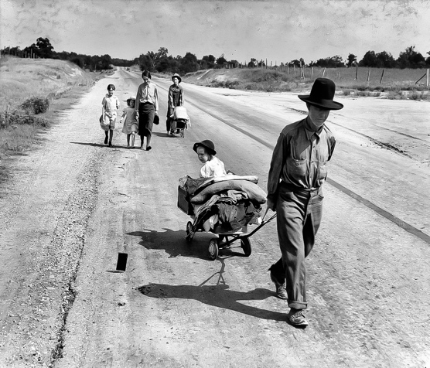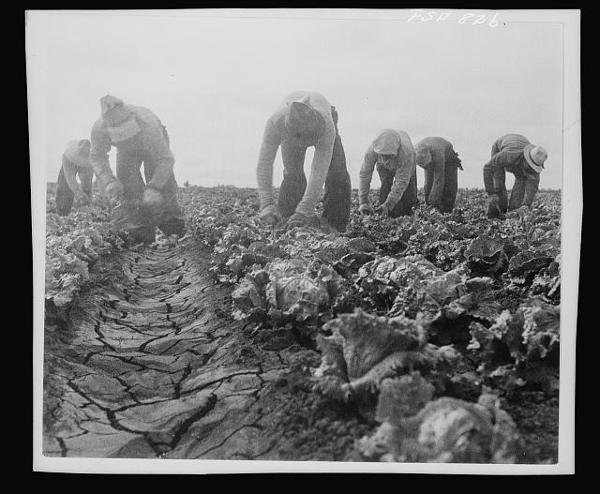

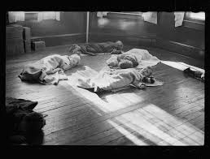
I think that these three photos show how genuinely hard it was to survive during the Great Depression. Children were sleeping on the hard floors because they could no longer have something to sleep on, farmers lands were beginning to dry out making it hard to grow crops, and some people had to give up everything just to hopefully survive.

